Field Work
On
E-Commerce Website
(Amazon)
Submitted
to
KCES’s Institute of Management and Research, Jalgaon



Submitted by
Name: Saloni Manoj Tidke
Email id: salonitidke55@gmail.com
Under the Guidance of
Name:Mr.Kulwant Mahale

In Partial Fulfillment of
Master of Computer Application [Integrated]

ACKNOWLEDGEMENT
I would like to express my sincere gratitude to my project guide for providing guidance and support during the preparation of this field work project.
I am thankful to KCE'S Institute of Management and Research, Jalgaon, for giving me the opportunity to undertake this project as part of the SY IMCA curriculum.
I would also like to thank all the respondents who participated in the questionnaire and shared their opinions and experiences regarding Amazon. Their responses provided the information required for the survey analysis.
Finally, I express my gratitude to my family and everyone who supported me in completing this project successfully.

TABLE OF CONTENTS
Sr. No. | Contents
1 | Certificate
2 | Declaration
3 | Acknowledgement
4 | Abstract
5 | Chapter 1: Introduction
6 | Chapter 2: Topic and Literature Review
7 | Chapter 3: Objectives of the Study
8 | Chapter 4: Research Methodology
9 | Chapter 5: Questionnaire
10 | Chapter 6: Results and Discussion
11 | Chapter 7: Major Findings
12 | Chapter 8: Suggestions and Recommendations
13 | Chapter 9: Conclusion
14 | Chapter 10: Limitations and Future Scope
15 | References

ABSTRACT
E-commerce has become an important part of modern life by allowing customers to purchase products and services through the internet. Amazon is one of the well-known online shopping platforms, offering a wide variety of products, customer reviews, different payment methods, delivery services, and return facilities.
The project entitled “A Study on the Usage and Customer Satisfaction of Amazon” aims to understand customers' shopping habits, preferences, experiences, and satisfaction with Amazon.
The study covers different factors, including shopping frequency, device usage, product prices, product quality, customer reviews, payment methods, delivery speed, packaging, return facilities, customer service, and overall satisfaction.
A structured questionnaire containing 30 multiple-choice questions was used for the survey. The charts supplied for this project represent 102 responses. The responses are analyzed using percentages, charts, and descriptive interpretations.
The survey results indicate that respondents generally report positive experiences with Amazon. However, concerns such as high prices and delivery issues are also visible in the responses.
The study helps identify important aspects of the customer experience and provides suggestions for improving online shopping services. The findings are limited to the respondents included in this survey.

CHAPTER 1: INTRODUCTION
1.1 Introduction to E-Commerce
E-commerce, also known as electronic commerce, refers to the buying and selling of goods and services through the internet. It allows customers to search for products, compare prices, place orders, and make payments electronically.
In recent years, e-commerce has changed the traditional shopping experience. Customers can purchase products from their homes without visiting physical stores. Online shopping platforms provide product information, photographs, customer reviews, ratings, and delivery options that help customers make purchasing decisions.
E-commerce is useful for both customers and businesses. Customers benefit from convenience and product variety, while businesses can reach a wider audience through online platforms.
1.2 Importance of E-Commerce
E-commerce plays an important role in the modern business environment. Its major benefits include:
- Convenience: Customers can shop from their homes or other locations.
- Time Saving: Customers can search for products without travelling to physical stores.
- Product Variety: Online platforms offer products from different categories.
- Price Comparison: Customers can compare prices and product features.
- Customer Reviews: Reviews and ratings help customers understand other buyers' experiences.
- Payment Options: Customers can choose from various available payment methods.
- Accessibility: Online shopping allows customers to browse products beyond their immediate local area.
These advantages have contributed to the growth of online shopping and the increasing use of e-commerce platforms.

1.3 OVERVIEW OF AMAZON
Amazon is a well-known e-commerce platform that enables customers to purchase products through the internet. It offers a wide range of products, including electronics, clothing, books, home appliances, beauty products, groceries, and many other items.
Customers can search for products, compare prices, read reviews, check ratings, and place orders through Amazon. The platform also provides order tracking, multiple payment options, delivery services, and return facilities according to the applicable conditions.
Amazon has contributed to the development of online shopping by making a large variety of products accessible through a digital platform. Customers can browse products and compare alternatives before making purchasing decisions.
1.4 Development of Online Shopping
Online shopping has become increasingly popular because of internet access, smartphones, digital payment services, and improvements in delivery systems. Customers can now explore products and complete purchases without visiting physical stores.
E-commerce platforms also help customers access product information and reviews before purchasing. At the same time, customers may face concerns related to product quality, pricing, delivery delays, and returns.
1.5 Importance of Amazon for Customers
Amazon provides customers with several useful facilities:
- Access to a wide variety of products.
- Product search and comparison features.
- Customer reviews and ratings.
- Different available payment methods.
- Order tracking facilities.
- Delivery and return services, subject to applicable conditions.
- Offers and discounts on selected products.
These facilities make Amazon a suitable platform for studying customer shopping behaviour and satisfaction.

1.6 FEATURES OF AMAZON
Amazon provides various features designed to support customers throughout the online shopping process.
1.6.1 Wide Product Range
Amazon offers products across numerous categories, allowing customers to explore different brands, prices, and product specifications on one platform.
1.6.2 Product Search
Customers can search for products using keywords and apply available filters to narrow their choices according to factors such as price, brand, and ratings.
1.6.3 Customer Reviews and Ratings
Customer reviews and ratings provide information about other buyers' experiences. They can help customers compare alternatives and make informed decisions.
1.6.4 Multiple Payment Methods
Amazon supports different payment methods depending on the transaction and availability. These may include UPI, credit or debit cards, net banking, and cash on delivery on eligible orders.
1.6.5 Delivery and Order Tracking
Customers can view order updates and track eligible orders. Delivery availability and timing may vary according to the product and delivery location.
1.6.6 Returns and Refunds
Eligible products may be returned according to the applicable return policy. The return process and refund timing depend on the product, order, and policy conditions.
1.6.7 Offers and Discounts
Amazon may provide discounts and special offers on selected products and during promotional events.
1.7 Purpose of Studying Amazon
The purpose of studying Amazon is to understand how customers use the platform and how they evaluate its services. The study examines convenience, pricing, product quality, reviews, payment methods, delivery, returns, and overall satisfaction.
The results can help identify the strengths of the customer experience and areas where improvement may be needed.

1.8 NEED AND SCOPE OF THE STUDY
1.8.1 Need for the Study
Online shopping has become an important part of the modern retail environment. Customers use e-commerce platforms to search for products, compare prices, read reviews, and place orders.
However, customer satisfaction may differ according to product quality, delivery speed, payment experience, return facilities, and customer service. Therefore, it is useful to understand customers' experiences with Amazon.
The need for this study arises from the following points:
- To understand customers' online shopping habits.
- To identify the factors that influence purchasing decisions.
- To study customer opinions about product quality and prices.
- To examine satisfaction with payment and delivery services.
- To understand customers' experiences with returns and refunds.
- To identify common problems faced while using Amazon.
- To study overall satisfaction and future purchase intentions.
1.8.2 Scope of the Study
The study focuses on customers' usage of Amazon and their satisfaction with its services. It covers shopping frequency, devices used, product searches, prices, reviews, ratings, payment methods, delivery, packaging, returns, customer service, and product variety.
The study uses a structured questionnaire containing 30 multiple-choice questions. The supplied survey charts represent 102 responses.
The analysis describes the opinions of these respondents. The findings should not automatically be considered representative of all Amazon customers.
1.8.3 Significance of the Study
This study is useful for understanding the factors that influence customers' online shopping experiences. It also helps identify areas where customers report satisfaction and areas where they experience difficulties.
The project provides practical learning about questionnaire preparation, survey data, charts, percentage analysis, and the interpretation of customer responses.

CHAPTER 2: TOPIC AND LITERATURE REVIEW
2.1 Introduction to the Topic
The topic selected for this field work project is “A Study on the Usage and Customer Satisfaction of Amazon.”
Amazon is an online shopping platform that allows customers to browse products, compare prices, read customer reviews, and purchase products through the internet. The platform provides various facilities that influence customers' online shopping experiences.
Customer satisfaction is an important aspect of e-commerce because it reflects how customers evaluate the products and services they receive. Factors such as product quality, price, delivery speed, payment security, and customer service may influence satisfaction.
This study examines the usage patterns and opinions of respondents who participated in the Amazon questionnaire survey.
2.2 Meaning of Customer Satisfaction
Customer satisfaction refers to the extent to which a product or service meets a customer's expectations and requirements.
In online shopping, customers may evaluate their experience based on whether the product matches its description, whether delivery is completed as expected, and whether payment and return processes are convenient.
A satisfactory shopping experience may encourage customers to purchase again and recommend the platform to others. An unsatisfactory experience may lead customers to compare alternatives or avoid future purchases.
2.3 Customer Behaviour in Online Shopping
Customer behaviour refers to the way people search for, evaluate, select, and purchase products.
Online shopping behaviour may be influenced by price, product availability, customer reviews, ratings, discounts, convenience, and delivery services.
Understanding customer behaviour helps explain why customers choose particular products and which features they consider important while shopping online.
The present study examines these aspects through a structured questionnaire containing 30 questions.

2.4 REVIEW OF RELEVANT CONCEPTS
2.4.1 Product Quality
Product quality is an important consideration in online shopping. Customers generally need products that meet their expectations and match the information provided on the website.
Product descriptions, images, specifications, and customer feedback can help customers evaluate products before purchasing.
2.4.2 Price and Discounts
Price can influence customers' purchase decisions. Customers may compare similar products and look for discounts or special offers before placing an order.
The present study includes questions about Amazon's product prices, offers, and discounts to understand their importance to respondents.
2.4.3 Customer Reviews and Ratings
Customer reviews and ratings provide information about other buyers' experiences. They may help customers compare products and evaluate their suitability.
The study examines how useful respondents find reviews and how frequently they check reviews before purchasing products.
2.4.4 Payment Methods and Security
A convenient and secure payment process is an important part of online shopping. Customers may prefer different payment methods according to their convenience and confidence.
The questionnaire examines preferred payment methods, satisfaction with Amazon's payment process, and respondents' feelings about online payment security.
2.4.5 Delivery and Packaging
Delivery speed and product packaging contribute to the shopping experience. Customers may be more satisfied when products arrive within the expected period and are appropriately packaged.
The study includes questions about delivery satisfaction, the importance of fast delivery, and packaging quality.
2.4.6 Returns and Customer Service
Customers may need to return products because of issues such as incorrect items, product defects, or differences between expectations and the received product.
A clear return process and helpful customer service can support a better customer experience. The questionnaire examines return experiences, return-process convenience, and satisfaction with customer service.

2.5 RESEARCH GAP
Online shopping involves several factors that can affect customer satisfaction. Customers may have different opinions about product quality, pricing, reviews, payment options, delivery services, and return facilities.
However, customer preferences and experiences may vary from one respondent to another. Therefore, it is useful to collect responses directly from customers and examine their opinions systematically.
The present project focuses on the responses collected through a 30-question questionnaire about Amazon. It considers both positive aspects of the shopping experience and problems reported by respondents.
The study uses the supplied survey charts representing 102 responses to summarize customer opinions and identify areas that may require improvement.
2.6 Relevance of the Study
This study is relevant because e-commerce platforms depend on customer trust, convenience, and satisfaction.
Understanding customers' experiences can help identify the factors they value most when shopping online. It can also highlight issues that may affect their willingness to recommend a platform or purchase from it again.
The questionnaire covers product quality, prices, reviews, payment methods, delivery speed, packaging, returns, customer service, product variety, and overall satisfaction.
2.7 Summary of the Literature Review
The concepts discussed in this chapter indicate that online shopping satisfaction can be influenced by multiple factors. These include product quality, price, customer reviews, payment convenience, delivery performance, and after-sales service.
The present project applies these concepts to a survey of Amazon users. The responses will be discussed in the following chapters using the actual charts and information supplied for the study.
Note: This literature review summarizes general concepts related to e-commerce and customer satisfaction. Specific published research studies should be added to the References section only when their details have actually been consulted and verified.

CHAPTER 3: OBJECTIVES OF THE STUDY
3.1 Main Objective
The main objective of this study is to understand the usage patterns and customer satisfaction of Amazon users.
3.2 Specific Objectives
The specific objectives of the study are:
- To study how frequently respondents shop on Amazon.
- To identify the devices commonly used for Amazon shopping.
- To understand customers' opinions about the ease of using Amazon.
- To examine the importance of price, quality, reviews, and ratings in purchase decisions.
- To study customer preferences regarding payment methods.
- To understand satisfaction with Amazon's payment process and payment security.
- To examine customer satisfaction with delivery speed and product packaging.
- To study customers' experiences with product returns and the return process.
- To understand satisfaction with product quality and customer service.
- To identify the importance of product variety, offers, and discounts.
- To identify the major problems customers face while using Amazon.
- To measure overall customer satisfaction.
- To understand whether respondents would recommend Amazon to others.
- To study whether respondents intend to purchase from Amazon again.
3.3 Research Questions
The study attempts to answer the following questions:
- How often do respondents shop on Amazon?
- Which factors influence their purchase decisions?
- How satisfied are respondents with Amazon's services?
- What are the most common problems experienced by respondents?
- Would respondents recommend Amazon or purchase from it again?
3.4 Importance of the Objectives
These objectives provide a clear direction for the research. They help organize the questionnaire, analyze the survey charts, and identify important patterns in customer responses.
The objectives also help connect the collected data with the final findings, suggestions, and conclusions of the project.

CHAPTER 4: RESEARCH METHODOLOGY
4.1 Introduction
Research methodology explains the methods used to conduct a study and achieve its objectives. It includes the research design, sample size, data sources, sampling method, data collection process, and techniques of analysis.
The present project studies Amazon usage and customer satisfaction through a structured questionnaire.
4.2 Research Design
The study follows a descriptive research approach. Descriptive research is used to summarize the characteristics, preferences, and opinions of respondents.
In this project, the responses are analyzed to understand shopping frequency, product preferences, payment methods, delivery experiences, and overall satisfaction.
4.3 Sample Size
The survey charts provided for this project represent 102 responses.
Particulars | Details
Minimum planned sample | 100 respondents
Responses represented in the charts | 102
Number of questionnaire questions | 30
4.4 Sources of Data
Primary Data
Primary data were collected through a structured questionnaire containing 30 multiple-choice questions related to Amazon usage and customer satisfaction.
Secondary Data
Secondary information about e-commerce and online shopping may be obtained from relevant books, educational materials, and official websites. Only sources actually consulted should be listed in the References section.
4.5 Research Instrument
A structured questionnaire was used as the main research instrument. It includes questions about shopping frequency, device usage, product quality, prices, reviews, payment methods, delivery, returns, customer service, and overall satisfaction.
Each question contains four answer options.
4.6 Method of Data Collection
The responses were collected through an online survey form, as indicated by the supplied response charts. The charts are used to summarize the answers to the questionnaire.
4.7 Method of Data Analysis
The data are presented through charts and descriptive interpretations. Percentages visible in the supplied charts are used to explain the response patterns.
4.8 Ethical Considerations
The study aims to present respondents' opinions honestly and protect their privacy. The analysis is based on the supplied survey information, and unsupported results are not added.

4.9 DATA ANALYSIS TECHNIQUES
Data analysis helps organize survey responses and present them in a meaningful form.
4.9.1 Percentage Analysis
Percentage analysis expresses the proportion of respondents who selected a particular answer.
The formula is:
Percentage = (Number of respondents selecting an option ÷ Total valid responses) × 100
For this project, the total number of responses represented in the supplied charts is 102.
4.9.2 Chart Analysis
Charts provide a visual presentation of responses. They help readers compare answer options and identify the most frequently selected responses.
The charts supplied for this project will be presented alongside the corresponding questionnaire questions in the Results and Discussion chapter.
4.9.3 Interpretation
Interpretation explains what the response distribution indicates. Each chart will be followed by a short explanation based on the visible percentages and response patterns.

4.10 Scope of the Methodology
The methodology focuses on the 30-question survey and the 102 responses represented in the charts. The analysis covers customer behaviour, purchasing preferences, satisfaction, and problems associated with using Amazon.
4.11 Limitations of the Methodology
The study has the following limitations:
- The findings are based on the 102 responses shown in the supplied charts.
- The findings may not represent every Amazon customer.
- Respondents may have different shopping habits and experiences.
- Some percentage labels may be too small to read clearly in the supplied screenshots.
- The study describes customer opinions and does not independently verify every purchase experience.
4.12 Summary
This chapter explained the research design, sample size, sources of data, questionnaire, data collection process, and analysis techniques.
The next chapter presents the questionnaire used for the study. The following chapter will present the survey charts and interpretations based on the collected responses.

CHAPTER 5
QUESTIONNAIRE
Topic: A Study on the Usage and Customer Satisfaction of Amazon
Instructions: Please select one option for each question. The information collected is used for academic research purposes.
Question 1. How often do you shop on Amazon?
A) Daily
B) Weekly
C) Monthly
D) Rarely
Question 2. Which device do you mainly use for Amazon?
A) Mobile
B) Laptop
C) Desktop
D) Tablet
Question 3. How easy is it to use Amazon?
A) Very Easy
B) Easy
C) Difficult
D) Very Difficult
Question 4. How often do you search for products on Amazon?
A) Very Frequently
B) Frequently
C) Sometimes
D) Rarely
Question 5. Which factor is most important when buying a product?
A) Price
B) Quality
C) Reviews & Ratings
D) Brand

Question 6. How useful are product reviews?
A) Very Useful
B) Useful
C) Slightly Useful
D) Not Useful
Question 7. How do you find Amazon product prices?
A) Very Affordable
B) Affordable
C) Expensive
D) Very Expensive
Question 8. Which payment method do you prefer?
A) UPI
B) Credit/Debit Card
C) Cash on Delivery
D) Net Banking
Question 9. How satisfied are you with Amazon's payment process?
A) Very Satisfied
B) Satisfied
C) Dissatisfied
D) Very Dissatisfied
Question 10. How satisfied are you with delivery speed?
A) Very Satisfied
B) Satisfied
C) Dissatisfied
D) Very Dissatisfied
Question 11. How do you rate product packaging?
A) Excellent
B) Good
C) Average
D) Poor
Question 12. Have you ever returned a product on Amazon?
A) Yes, frequently
B) Yes, once or twice
C) No
D) Not Sure
Question 13. How easy is the return process?
A) Very Easy
B) Easy
C) Difficult
D) Very Difficult
Question 14. How satisfied are you with product quality?
A) Very Satisfied
B) Satisfied
C) Dissatisfied
D) Very Dissatisfied
Question 15. How satisfied are you with Amazon's customer service?
A) Very Satisfied
B) Satisfied
C) Dissatisfied
D) Very Dissatisfied
Question 16. How important is Amazon's product rating to you?
A) Very Important
B) Important
C) Less Important
D) Not Important
Question 17. Do you compare products before purchasing?
A) Always
B) Often
C) Sometimes
D) Never
Question 18. Do you use Amazon offers/discounts?
A) Always
B) Often
C) Sometimes
D) Never
Question 19. How satisfied are you with Amazon's product variety?
A) Very Satisfied
B) Satisfied
C) Dissatisfied
D) Very Dissatisfied
Question 20. How important is fast delivery to you?
A) Very Important
B) Important
C) Less Important
D) Not Important
Question 21. How satisfied are you with Amazon overall?
A) Very Satisfied
B) Satisfied
C) Dissatisfied
D) Very Dissatisfied
Question 22. Would you recommend Amazon to others?
A) Definitely Yes
B) Probably Yes
C) Probably No
D) Definitely No
Question 23. Would you purchase from Amazon again?
A) Definitely Yes
B) Probably Yes
C) Probably No
D) Definitely No
Question 24. What is the biggest problem you face while using Amazon?
A) High Price
B) Delivery Issues
C) Product Quality
D) Return/Refund Issues
Question 25. Overall, how would you rate Amazon?
A) Excellent
B) Good
C) Average
D) Poor

Question 26. How did you first learn about Amazon?
A) Friends and Family
B) Social Media
C) Television Advertisements
D) Internet Search
Question 27. How often do you check product reviews before purchasing?
A) Always
B) Often
C) Sometimes
D) Never
Question 28. Are you satisfied with the accuracy of product descriptions on Amazon?
A) Very Satisfied
B) Satisfied
C) Dissatisfied
D) Very Dissatisfied
Question 29. What encourages you most to purchase products from Amazon?
A) Discounts and Offers
B) Product Variety
C) Fast Delivery
D) Customer Reviews
Question 30. How secure do you feel while making online payments on Amazon?
A) Very Secure
B) Secure
C) Somewhat Secure
D) Not Secure

CHAPTER 6
RESULTS AND DISCUSSION
6.1 Introduction
This chapter presents the analysis and interpretation of the responses collected through the questionnaire on the usage and customer satisfaction of Amazon. The survey received responses from 102 respondents.
The collected responses are presented using charts to make the findings easy to understand. Each question is analysed separately to identify customer preferences, shopping habits, satisfaction levels, and problems faced while using Amazon.
The analysis focuses on the following areas:
- Online shopping frequency and device preferences.
- Product selection and the importance of reviews.
- Pricing and payment preferences.
- Delivery, packaging, and return services.
- Product quality and customer service.
- Overall satisfaction and customer loyalty.
- Problems faced by customers and factors influencing purchases.
The charts included in this chapter are based on the survey responses. The interpretations describe the major response patterns observed in the charts.

6.2 Demographic Profile of Respondents
Age Distribution of Respondents
The age distribution chart presents the age profile of the respondents who participated in the survey. Understanding the respondents' age groups helps provide background information about the people included in the study.

Insert Chart:

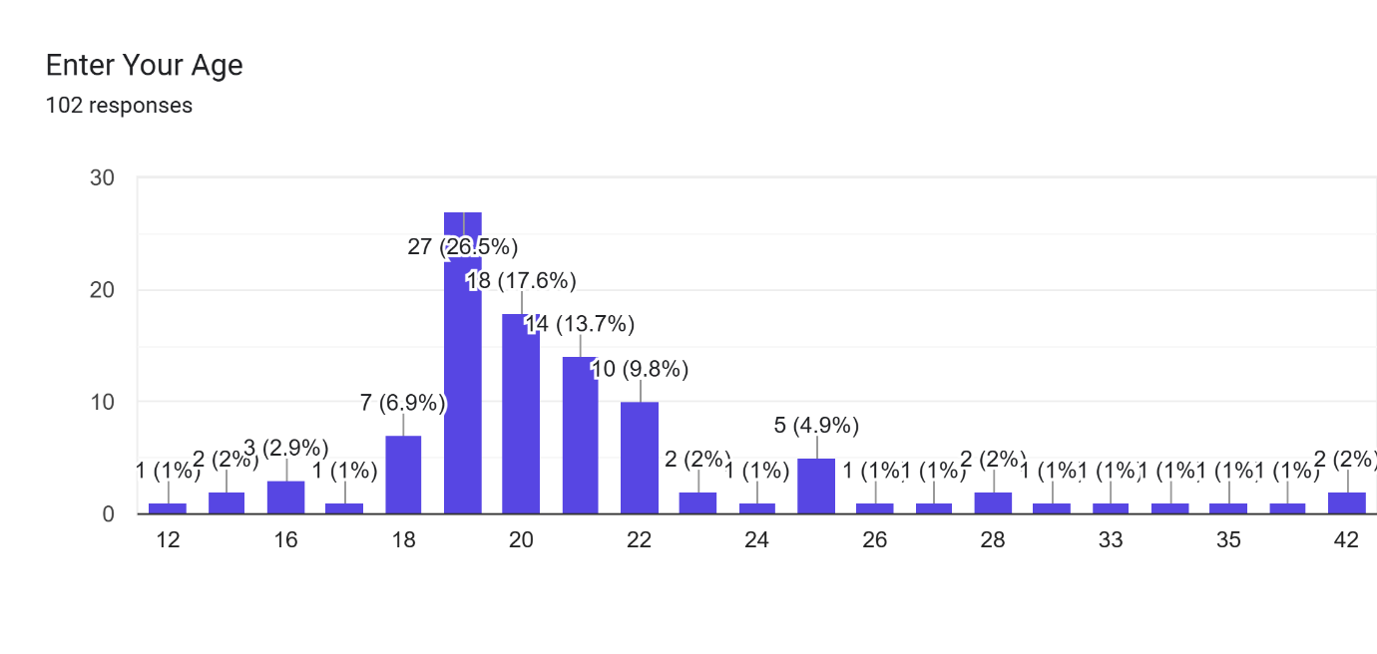
Interpretation:
The chart shows the age distribution of the 102 respondents. It provides an overview of the different age groups represented in the survey. This information helps describe the sample selected for studying Amazon usage and customer satisfaction.
The findings in this section describe only the respondents who participated in the survey and should not automatically be considered representative of all Amazon customers.

6.3 Analysis of Question 1: Shopping Frequency
Question: How often do you shop on Amazon?
Insert Chart:
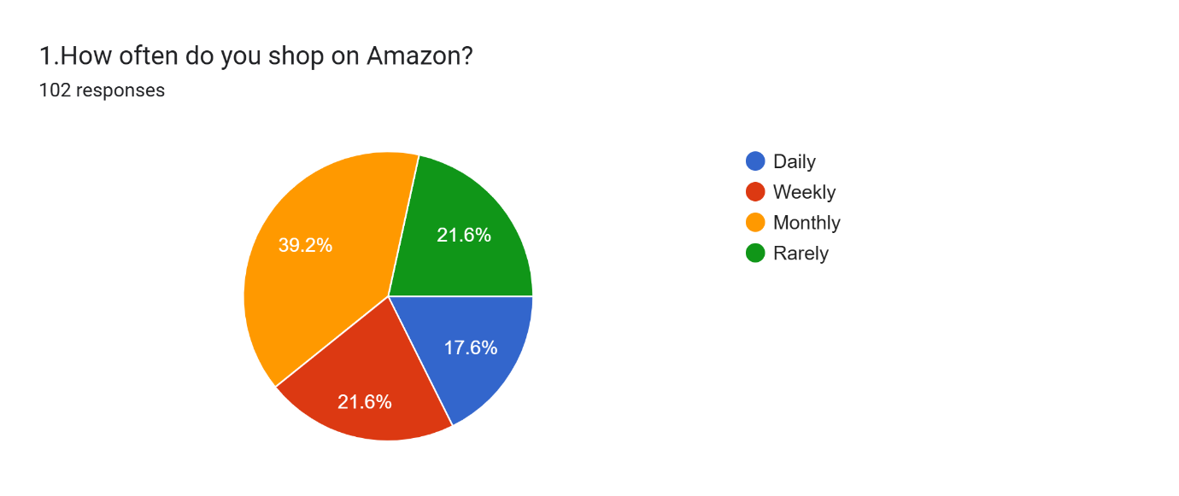
Interpretation:
The survey results indicate that 39.2% of respondents shop on Amazon monthly. Weekly and rarely shopping each account for 21.6% of respondents, while 17.6% shop daily.
The results suggest that monthly shopping is the most common frequency among the surveyed respondents. The responses also show that Amazon is used by customers with different shopping habits.
6.4 Analysis of Question 2: Device Preference
Question: Which device do you mainly use for Amazon?
Insert Chart: Paste the chart for Question 2 here.
Interpretation:
The chart indicates that 74.5% of respondents mainly use mobile devices to access Amazon. Laptop users account for 15.7%, while the remaining respondents use desktop computers and tablets.
The results show that mobile devices are the most commonly used option among the respondents. This highlights the importance of a convenient and user-friendly mobile shopping experience.

6.5 Analysis of Question 3: Ease of Using Amazon
Question: How easy is it to use Amazon?
Insert Chart:
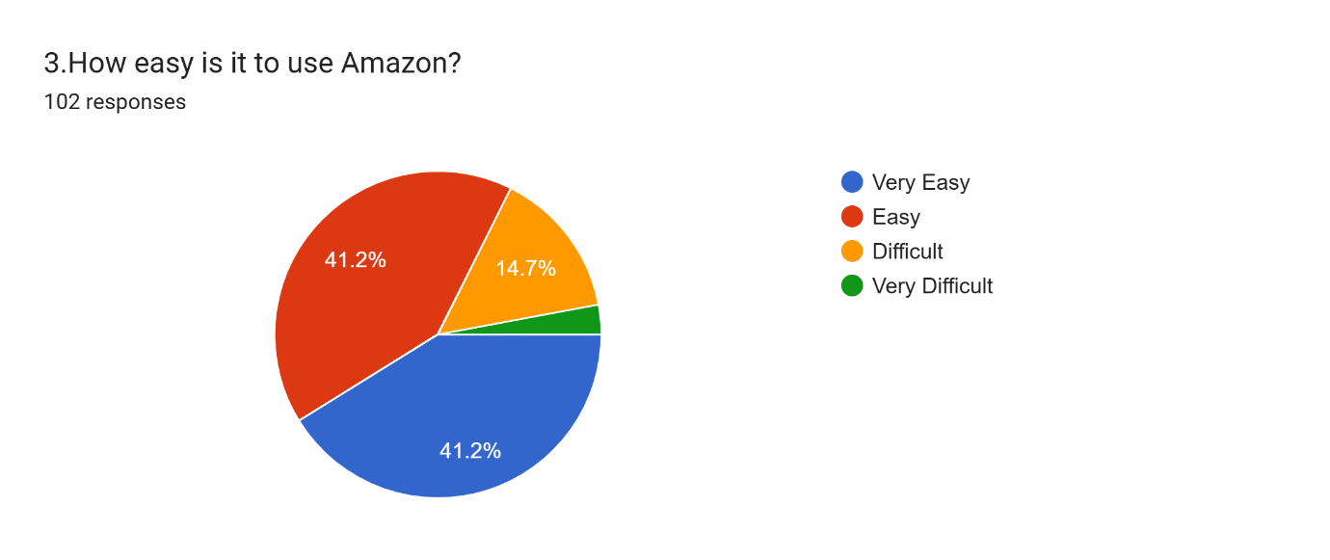
Interpretation:
The results show that 41.2% of respondents find Amazon very easy to use, while another 41.2% find it easy. A smaller proportion reported difficulty using the platform.
These responses indicate that most surveyed customers find Amazon easy to use. A simple interface and convenient product-search features may contribute to a positive shopping experience.
6.6 Analysis of Question 4: Frequency of Product Searching
Question: How often do you search for products on Amazon?
Insert Chart: 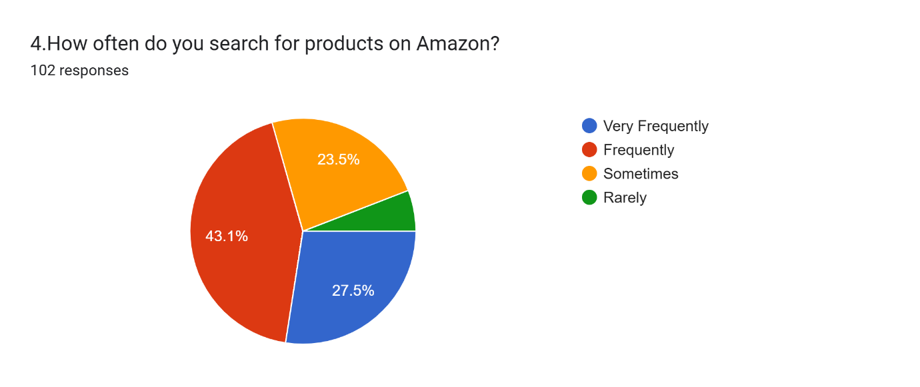

Interpretation:
According to the chart, 43.1% of respondents frequently search for products on Amazon, while 27.5% do so very frequently. Another 23.5% search sometimes.
The findings suggest that most respondents use Amazon's search facility regularly. Effective search options and clear product information can help customers find products more conveniently.

6.7 Analysis of Question 5: Important Factor in Product Selection
Question: Which factor is most important when buying a product?
Insert Chart: 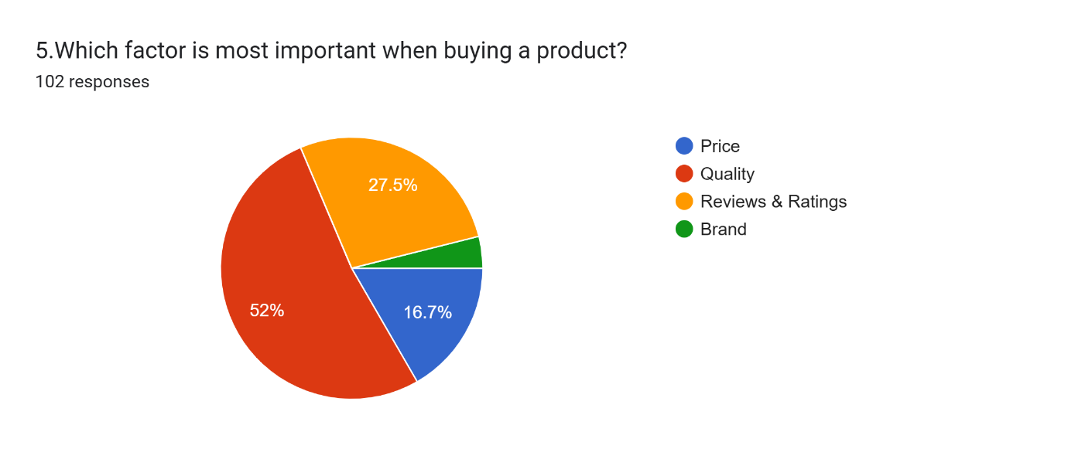
Interpretation:
The survey shows that product quality is the most important factor for 52% of respondents. Reviews and ratings are selected by 27.5%, while price is selected by 16.7%. Brand accounts for the remaining responses.
The results suggest that product quality plays a major role in purchase decisions among the surveyed customers. Reviews and ratings also help customers evaluate products before making a purchase.

6.8 Analysis of Question 6: Usefulness of Product Reviews
Question: How useful are product reviews?
Insert Chart: 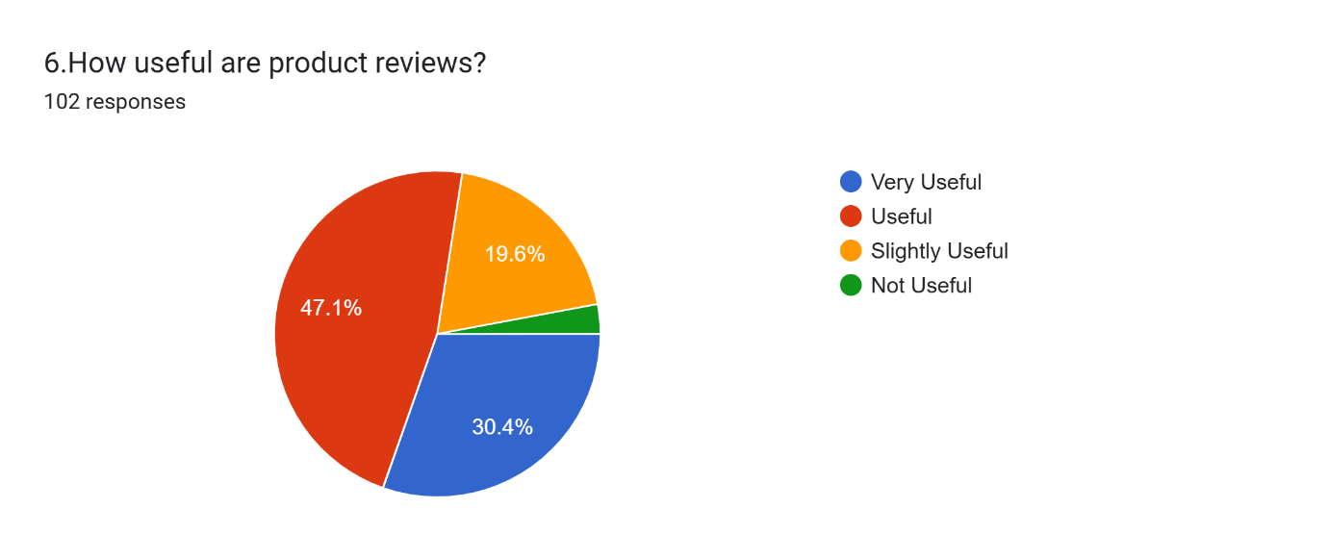
Interpretation:
The chart indicates that 47.1% of respondents find product reviews useful, while 30.4% consider them very useful. The remaining respondents report that reviews are slightly useful or not useful.
Overall, most respondents consider product reviews helpful when shopping online. Reviews can provide additional information about product experiences and support informed purchasing decisions.

6.9 Analysis of Question 7: Amazon Product Prices
Question: How do you find Amazon product prices?
Insert Chart: 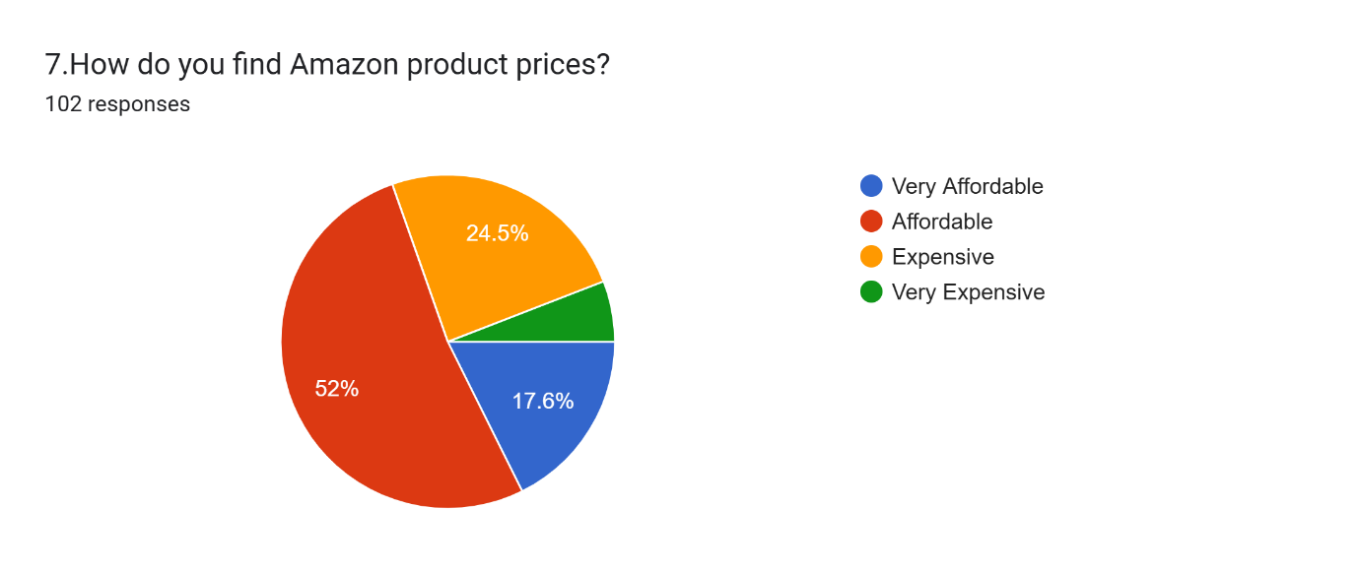
Interpretation:
The survey results indicate that 52% of respondents consider Amazon product prices affordable, while 17.6% consider them very affordable. However, 24.5% of respondents find the prices expensive.
The findings suggest that more than half of the surveyed respondents have a positive view of Amazon's product prices. However, price remains an important consideration for customers when making online purchases.
6.10 Analysis of Question 8: Preferred Payment Method
Question: Which payment method do you prefer?
Insert Chart: 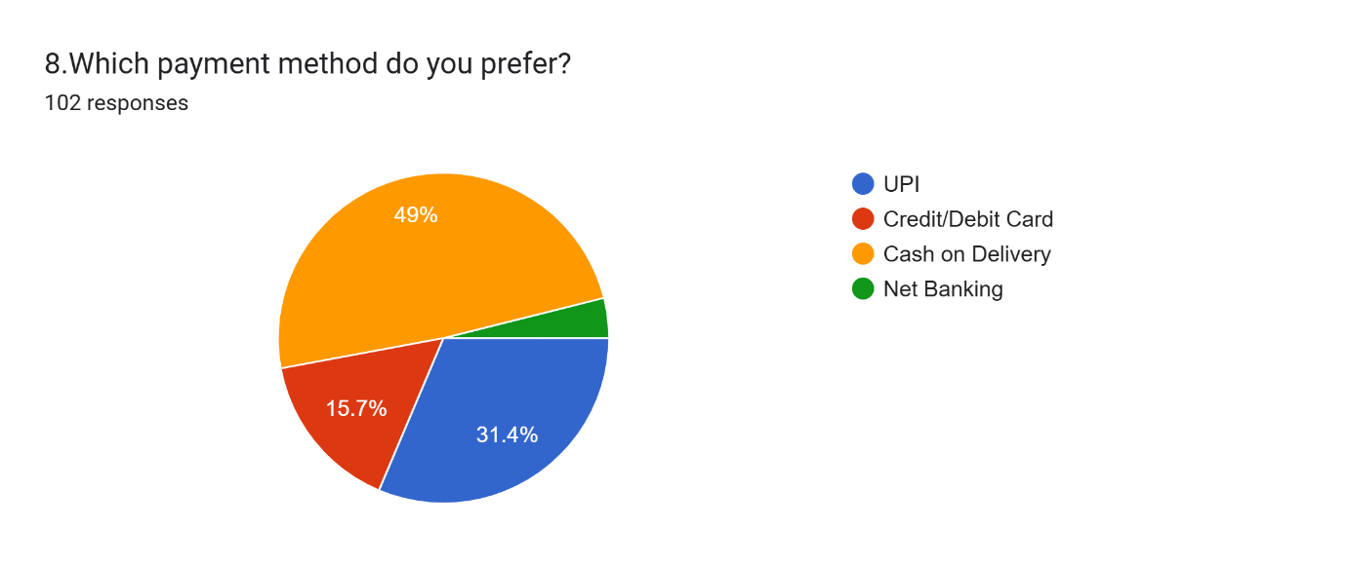

Interpretation:
The chart shows that Cash on Delivery is the preferred payment method for 49% of respondents. UPI is preferred by 31.4%, while 15.7% prefer credit or debit cards. The remaining respondents prefer net banking.
The results indicate that Cash on Delivery is the most preferred payment option among the surveyed respondents, followed by UPI. Offering convenient payment choices may help improve the shopping experience.

6.11 Analysis of Question 9: Satisfaction with the Payment Process
Question: How satisfied are you with Amazon's payment process?
Insert Chart: 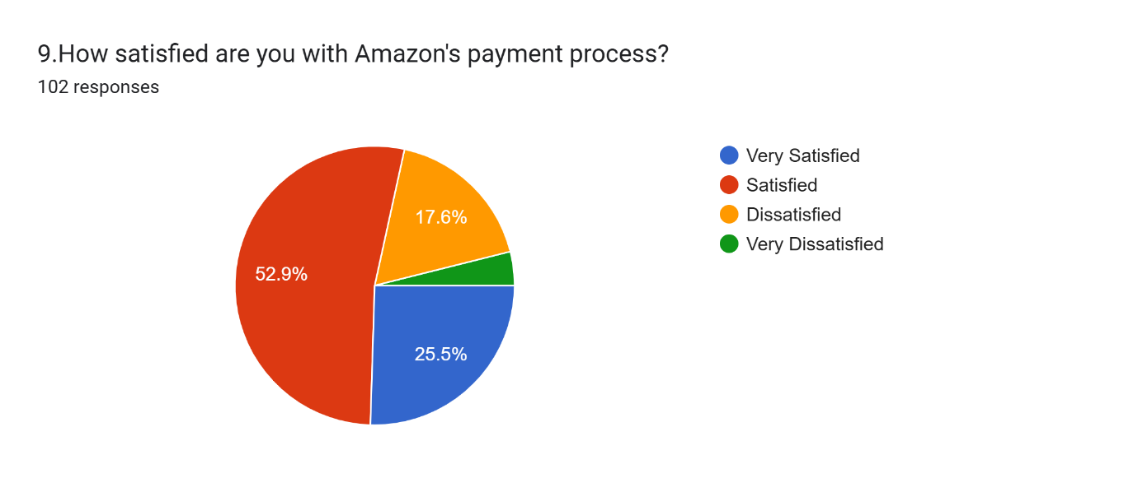
Interpretation:
The results show that 52.9% of respondents are satisfied with Amazon's payment process, while 25.5% are very satisfied. The remaining respondents reported dissatisfaction at different levels.
The findings indicate that most surveyed customers are satisfied with the payment process. A smooth and convenient payment experience is important for completing online purchases.

6.12 Analysis of Question 10: Satisfaction with Delivery Speed
Question: How satisfied are you with delivery speed?
Insert Chart: 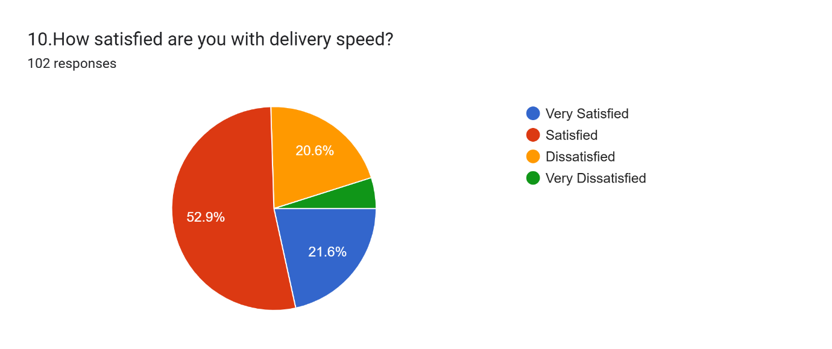

Interpretation:
According to the chart, 52.9% of respondents are satisfied with Amazon's delivery speed, while 21.6% are very satisfied. Other respondents reported different levels of dissatisfaction.
The results suggest that most respondents are satisfied with delivery speed. However, maintaining consistent and timely delivery remains important for improving customer satisfaction.

6.13 Analysis of Question 11: Product Packaging
Question: How do you rate product packaging?Insert Chart: 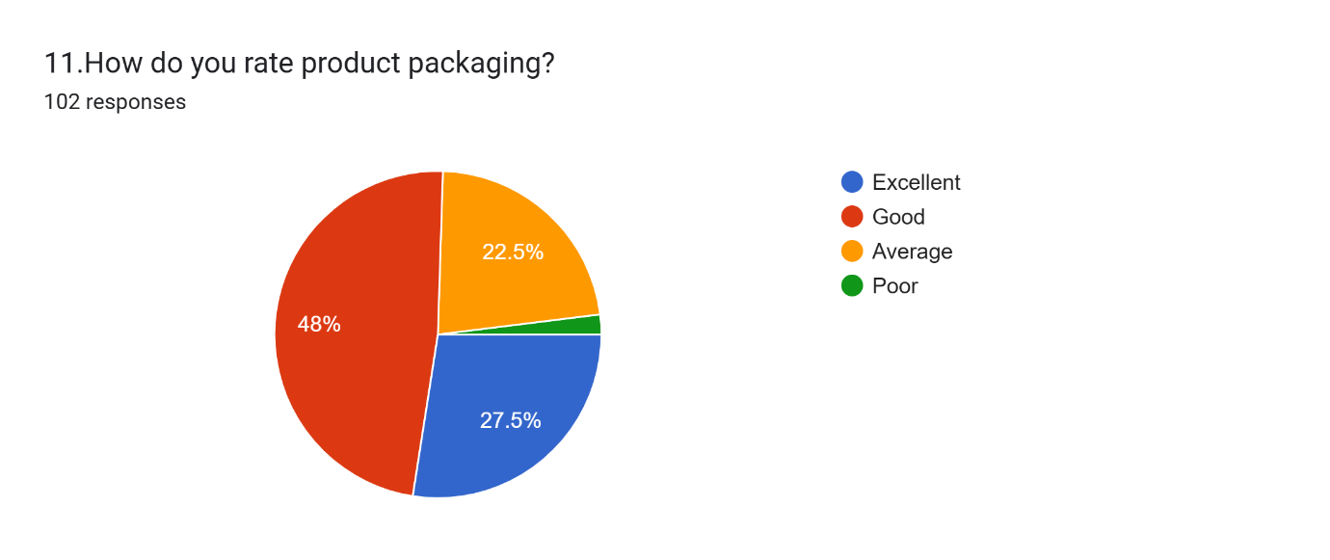
Interpretation:
The chart indicates that 48% of respondents rate Amazon's product packaging as good, while 27.5% rate it as excellent. Around 22.5% rate the packaging as average.
The findings show that most respondents have a positive opinion of product packaging. Proper packaging is important for protecting products during transportation and helping them reach customers in satisfactory condition.
6.14 Analysis of Question 12: Product Returns
Question: Have you ever returned a product on Amazon?
Insert Chart: 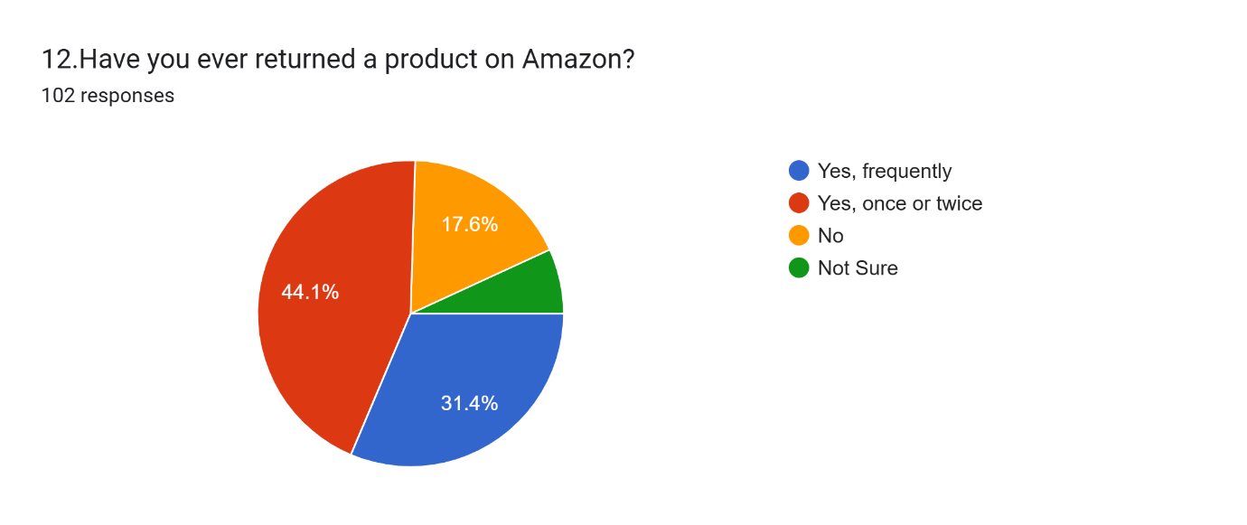

Interpretation:
The survey results show that 44.1% of respondents have returned products once or twice, while 31.4% report returning products frequently. Another 17.6% have not returned a product. The remaining respondents selected the unsure option.
The findings indicate that product returns are a common experience among the surveyed respondents. A clear return policy and a convenient return process can help customers manage unsuitable or unsatisfactory purchases.

6.15 Analysis of Question 13: Ease of the Return Process
Question: How easy is the return process?
Insert Chart: 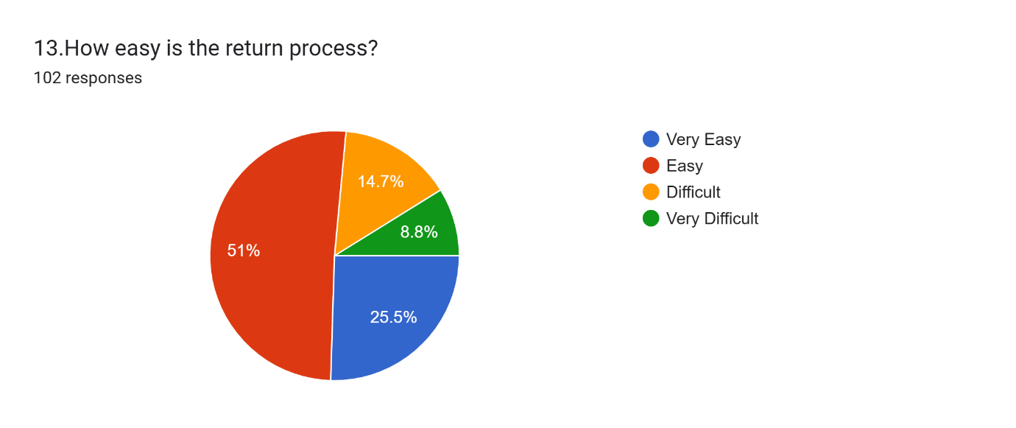
Interpretation:
The survey results indicate that 51% of respondents find Amazon's return process easy, while 25.5% consider it very easy. Some respondents reported difficulty with the process, including 8.8% who selected very difficult.
The findings suggest that most surveyed respondents find the return process convenient. However, simplifying return procedures and providing clear instructions may further improve the customer experience.

6.16 Analysis of Question 14: Satisfaction with Product Quality
Question: How satisfied are you with product quality?
Insert Chart: 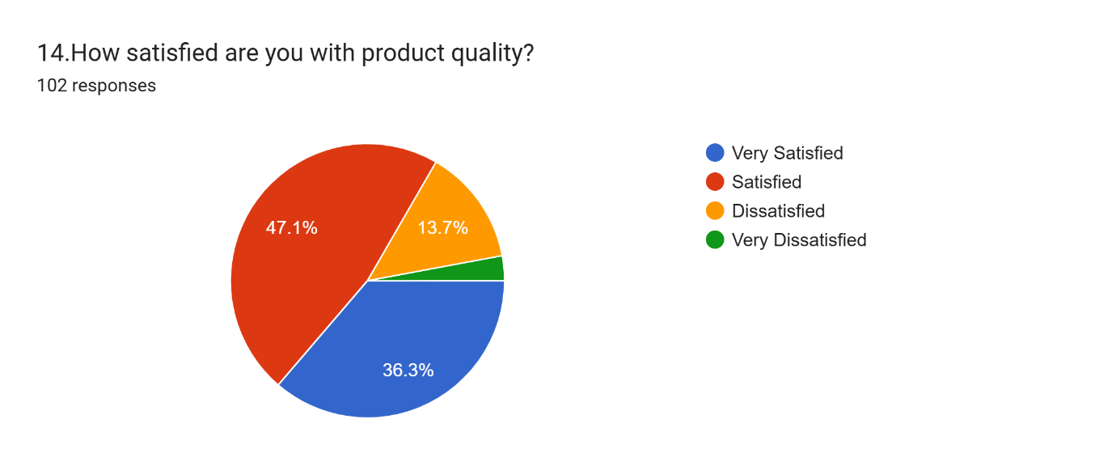
Interpretation:
The chart shows that 47.1% of respondents are satisfied with product quality, while 38.3% are very satisfied. The remaining respondents reported dissatisfaction at different levels.
The results indicate that most respondents are satisfied with the quality of products purchased through Amazon. Maintaining product standards and ensuring that products match their descriptions can help strengthen customer trust.

6.17 Analysis of Question 15: Satisfaction with Customer Service
Question: How satisfied are you with Amazon's customer service?
Insert Chart: 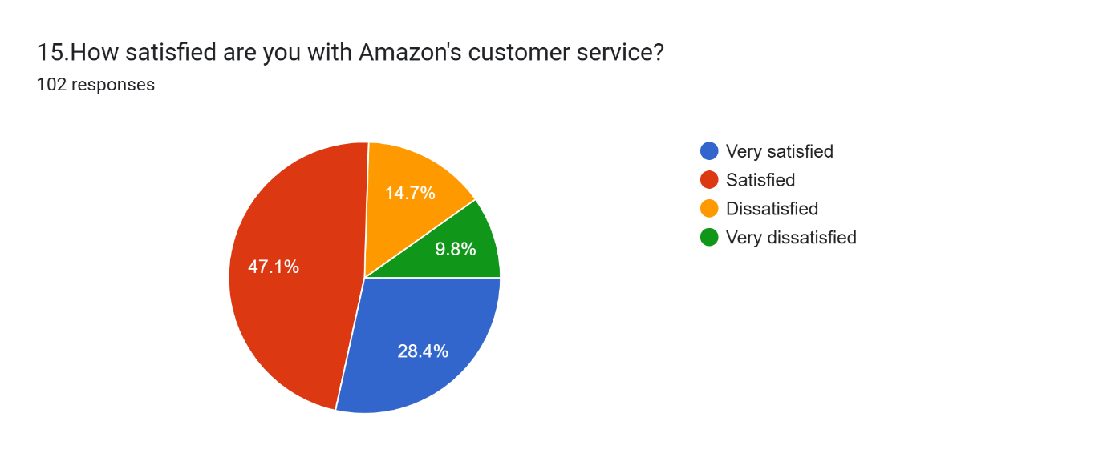
Interpretation:
The survey results indicate that 47.1% of respondents are satisfied with Amazon's customer service, while 28.4% are very satisfied. Other respondents reported dissatisfaction at different levels.
The findings suggest that most respondents have a positive opinion of customer service. Prompt responses, clear communication, and effective complaint resolution may help improve customer satisfaction further.

6.18 Analysis of Question 16: Importance of Product Ratings
Question: How important is Amazon's product rating to you?
Insert Chart: 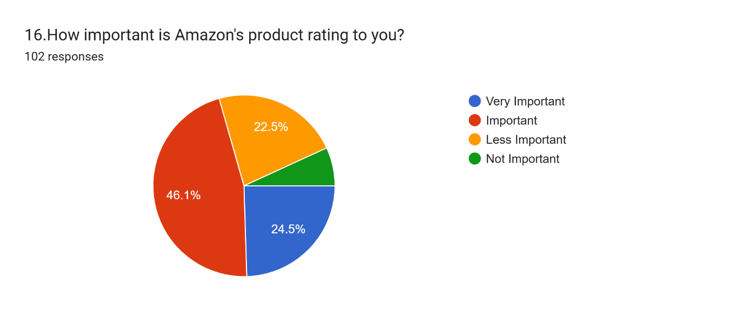

Interpretation:
The chart indicates that 46.1% of respondents consider product ratings important, while 24.5% consider them very important. The remaining respondents consider ratings less important or not important.
The results show that product ratings influence many respondents when they evaluate products. Ratings can help customers compare alternatives and make more informed purchase decisions.
6.19 Analysis of Question 17: Product Comparison Before Purchase
Question: Do you compare products before purchasing?
Insert Chart: 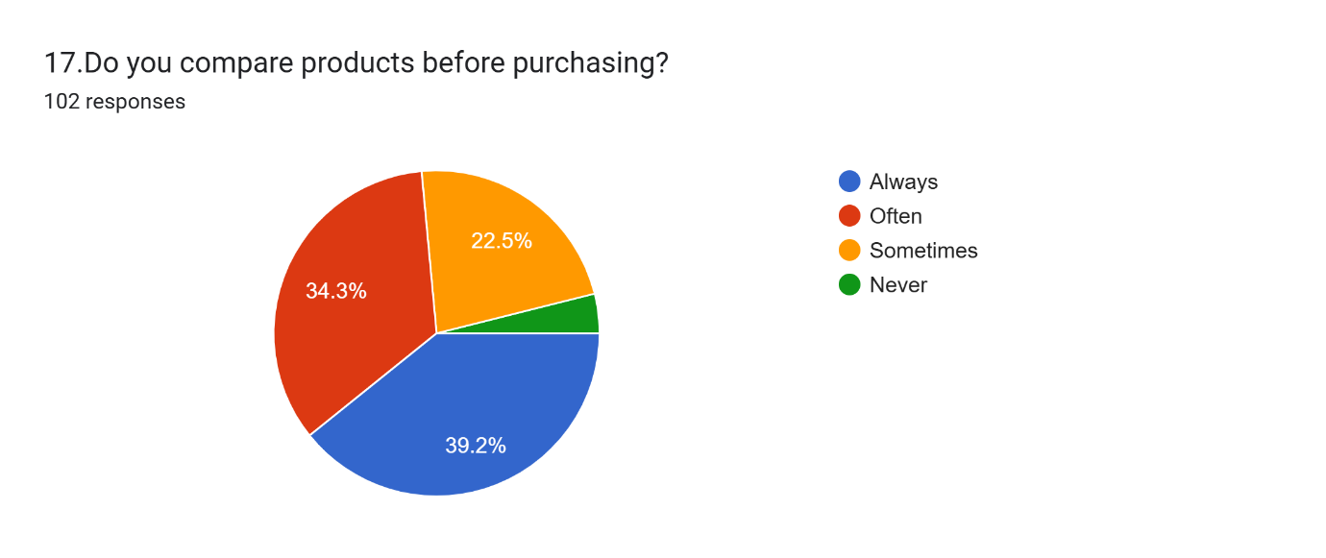
Interpretation:
The survey results show that 39.2% of respondents always compare products before purchasing, while 34.3% often compare products. The remaining respondents compare products sometimes or never.
The findings indicate that comparing products is a common shopping habit among the respondents. Product specifications, prices, ratings, and customer reviews may help customers choose suitable products.
6.20 Analysis of Question 18: Use of Offers and Discounts
Question: Do you use Amazon offers/discounts?
Insert Chart: 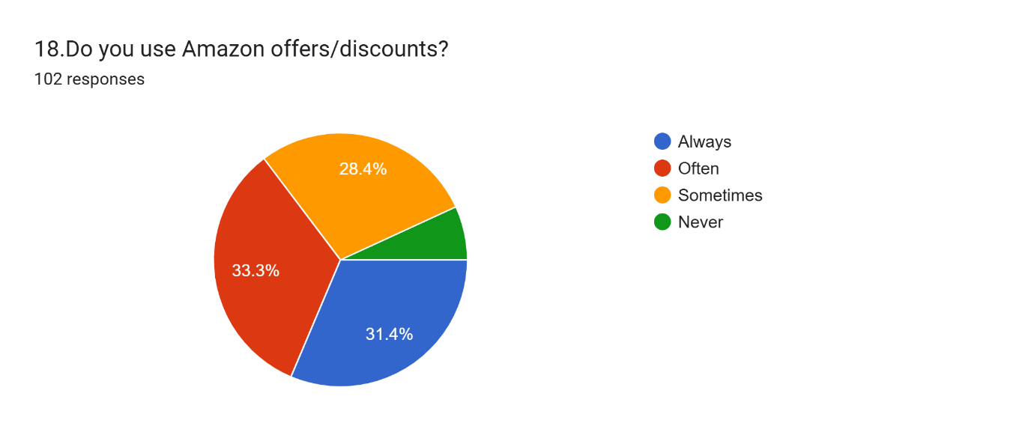
Interpretation:
The chart indicates that 33.3% of respondents often use Amazon offers and discounts, while 31.4% always use them. Another 28.4% use offers sometimes.
The results suggest that offers and discounts are an important part of shopping behaviour among the surveyed respondents. Attractive deals may encourage purchases, although customers may also consider product quality and other factors.

6.21 Analysis of Question 19: Satisfaction with Product Variety
Question: How satisfied are you with Amazon's product variety ?
Insert Chart: 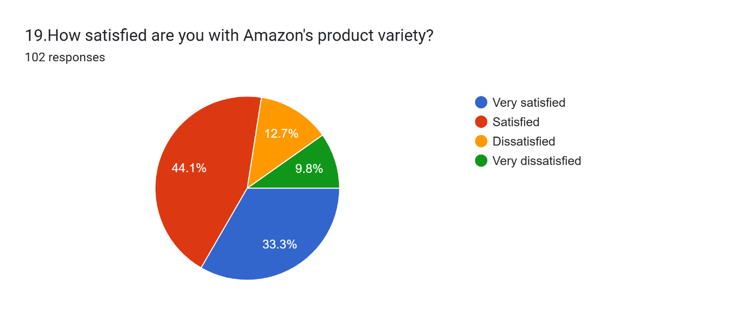
Interpretation:
The survey results indicate that 44.1% of respondents are satisfied with Amazon's product variety, while 33.3% are very satisfied. The remaining respondents reported dissatisfaction at different levels.
The findings suggest that most respondents are satisfied with the variety of products available on Amazon. A wide selection of products allows customers to explore different brands, categories, and alternatives according to their preferences.
6.22 Analysis of Question 20: Importance of Fast Delivery
Question: How important is fast delivery to you?
Insert Chart: 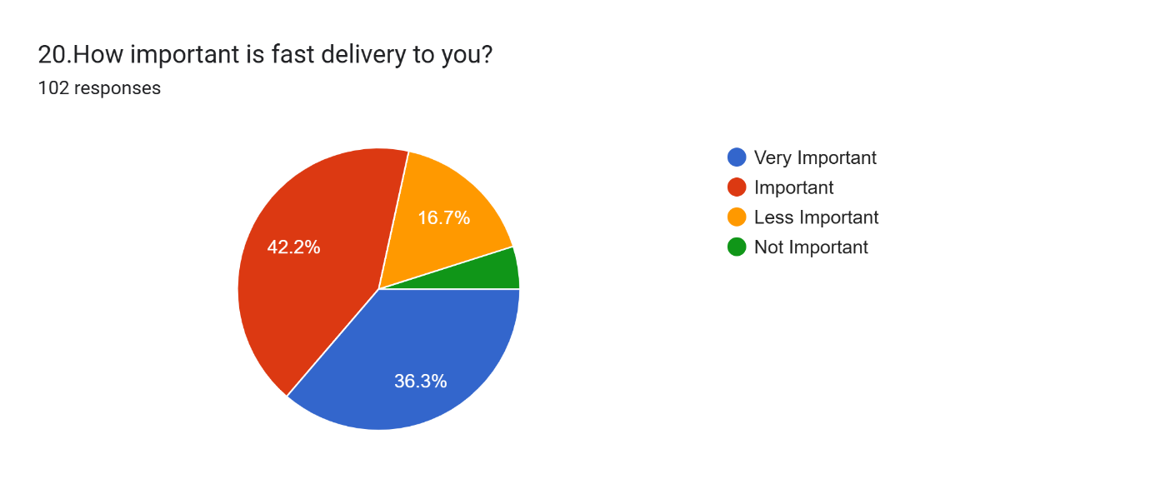

Interpretation:
The chart shows that 42.2% of respondents consider fast delivery important, while 33.3% consider it very important. Other respondents consider it less important or not important.
The results indicate that fast delivery is an important consideration for most surveyed respondents. Timely delivery can improve convenience and contribute to a positive online shopping experience.

6.23 Analysis of Question 21: Overall Customer Satisfaction
Question: How satisfied are you with Amazon overall?
Insert Chart: 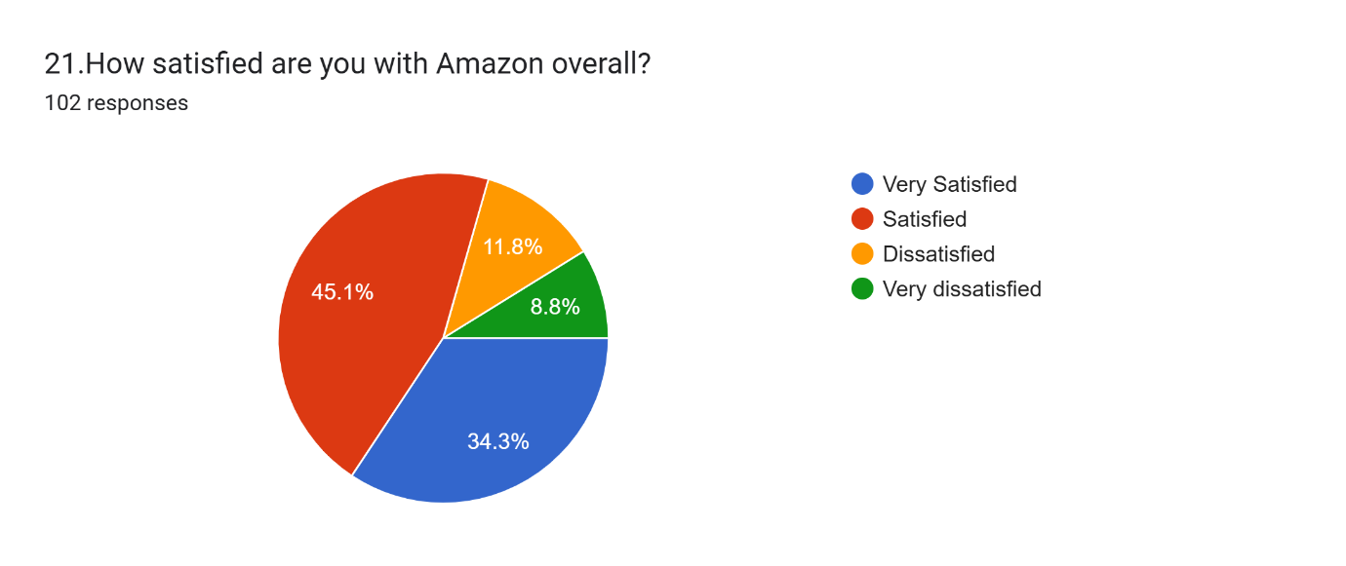
Interpretation:
The survey results show that 45.1% of respondents are satisfied with Amazon overall, while 34.3% are very satisfied. The remaining respondents reported dissatisfaction at different levels.
The findings suggest that overall customer satisfaction is positive among the surveyed respondents. Product variety, payment convenience, delivery services, and product information may contribute to their shopping experience.

6.24 Analysis of Question 22: Recommendation to Others
Question: Would you recommend Amazon to others?
Insert Chart: 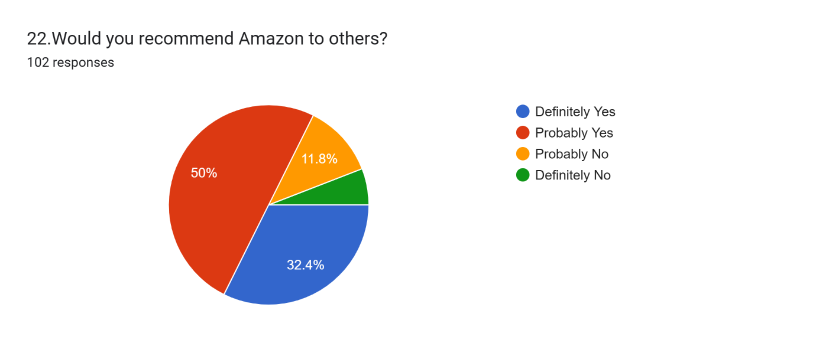
Interpretation:
The chart indicates that 50% of respondents would probably recommend Amazon to others, while 32.4% would definitely recommend it. The remaining respondents selected one of the negative recommendation options.
The results suggest that most respondents are willing to recommend Amazon to other people. Positive shopping experiences may encourage customers to share their recommendations with friends and family.

6.25 Analysis of Question 23: Intention to Purchase Again
Question: Would you purchase from Amazon again?
Insert Chart: 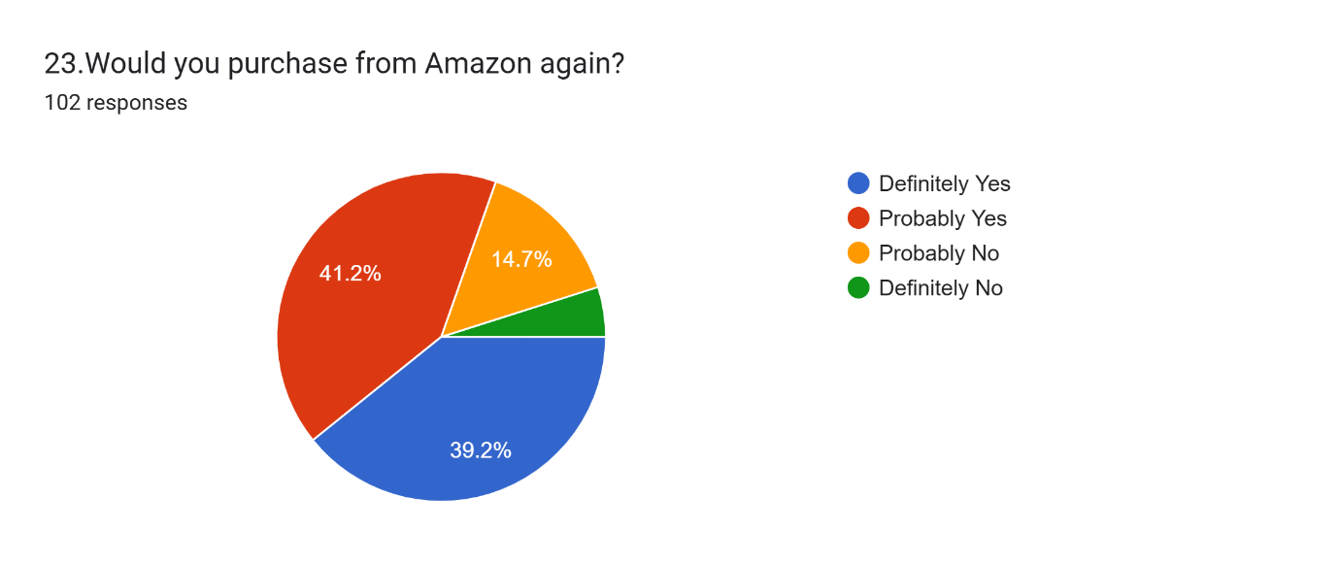
Interpretation:
The survey results indicate that 41.2% of respondents would probably purchase from Amazon again, while 39.2% would definitely do so. The remaining respondents selected negative responses.
The findings suggest that most respondents show a positive intention to purchase from Amazon in the future. Customer satisfaction, product availability, convenient payment options, and delivery services may influence repeat purchases.
6.26 Analysis of Question 24: Problems Faced While Using Amazon
Question: What is the biggest problem you face while using Amazon?
Insert Chart: 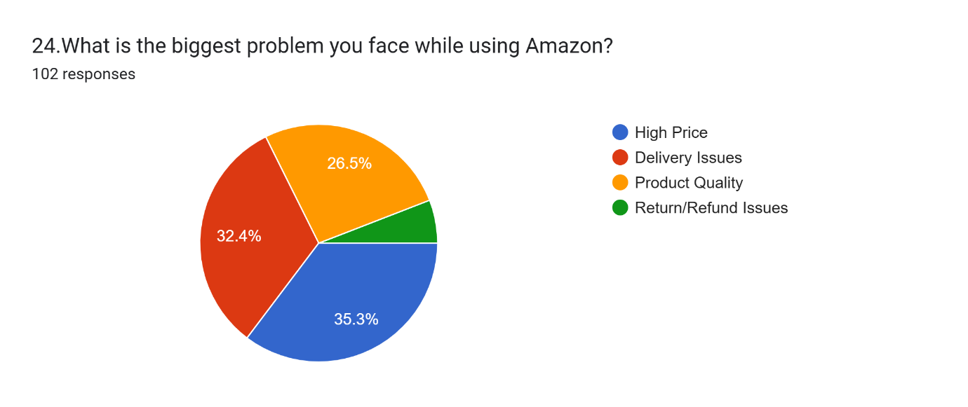

Interpretation:
The chart shows that high prices are the biggest problem for 35.3% of respondents, followed by delivery issues at 32.4%. Product quality accounts for 26.5%, while the remaining respondents selected return or refund issues.
The findings indicate that pricing and delivery are important concerns among the surveyed respondents. Amazon could focus on competitive pricing, reliable delivery, accurate product information, and efficient return procedures to improve the customer experience.

6.27 Analysis of Question 25: Overall Rating of Amazon
Question: Overall, how would you rate Amazon?
Insert Chart: 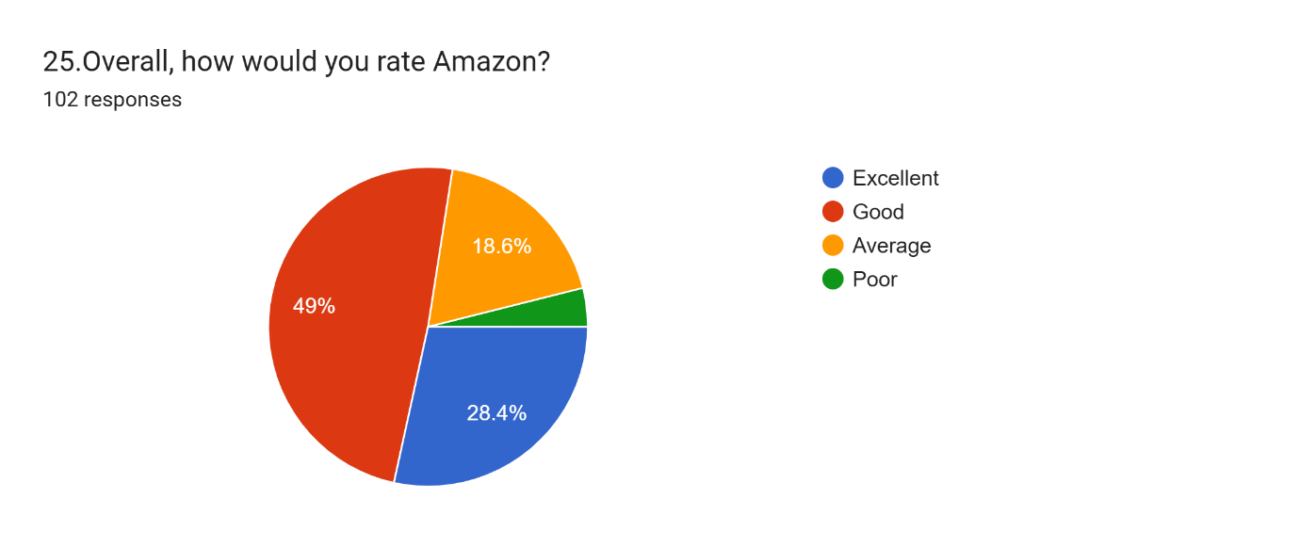
Interpretation:
The survey results indicate that 49% of respondents rate Amazon as good, while 28.4% rate it as excellent. Around 18.6% rate Amazon as average, and the remaining respondents rate it as poor.
The findings suggest that most surveyed respondents have a positive overall opinion of Amazon. However, continued improvements in pricing, delivery, and customer service may help improve customer ratings.

6.28 Analysis of Question 26: Awareness of Amazon
Question: How did you first learn about Amazon?
Insert Chart: 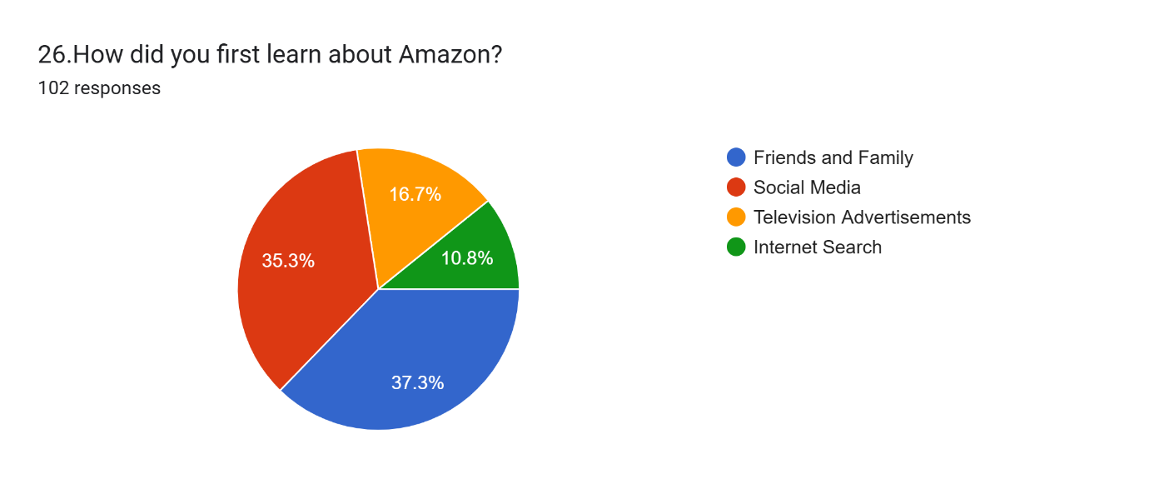
Interpretation:
The chart shows that 37.3% of respondents first learned about Amazon through friends and family, while 35.3% learned about it through social media. The remaining respondents selected television advertisements or internet search.
The findings indicate that personal recommendations and social media are important sources of awareness among the surveyed respondents. This highlights the

6.29 Analysis of Question 27: Checking Product Reviews
Question: How often do you check product reviews before purchasing?
Insert Chart: 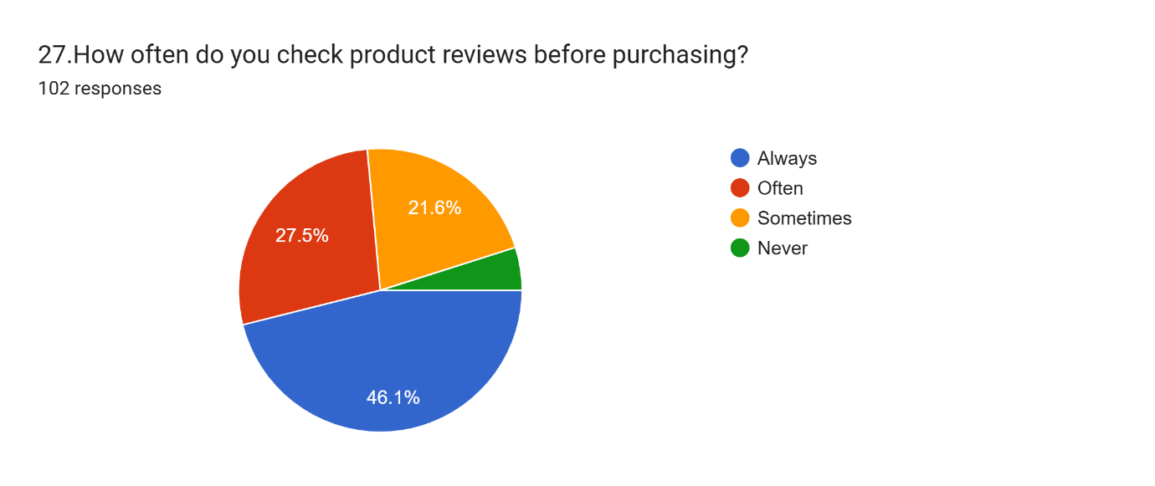
Interpretation:
The survey results show that 46.1% of respondents always check product reviews before purchasing, while 27.5% often check reviews. The remaining respondents check reviews sometimes or never.
The findings suggest that product reviews are an important source of information for many respondents. Reading reviews may help customers understand other buyers' experiences before making purchase decisions.

6.30 Analysis of Question 28: Accuracy of Product Descriptions
Question: Are you satisfied with the accuracy of product descriptions on Amazon?
Insert Chart: 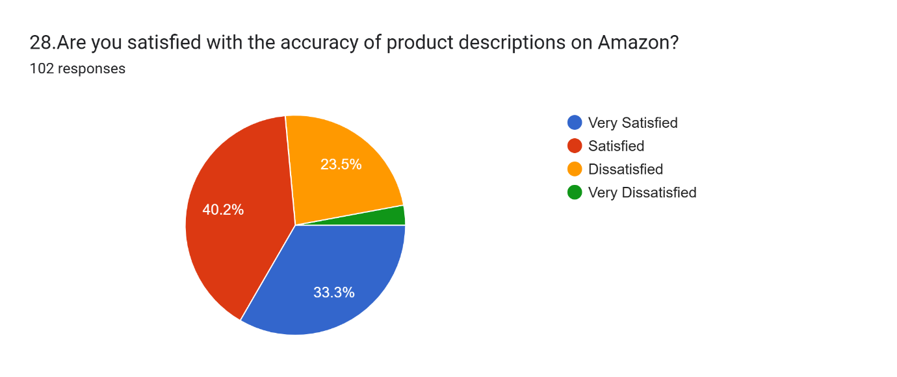
Interpretation:
The chart indicates that 40.2% of respondents are satisfied with the accuracy of product descriptions, while 33.3% are very satisfied. The remaining respondents reported dissatisfaction at different levels.
The results suggest that most surveyed respondents are satisfied with the product information provided on Amazon. Accurate descriptions, specifications, and images can help customers make informed decisions and reduce misunderstandings about products.

6.31 Analysis of Question 29: Factors Encouraging Purchases
Question: What encourages you most to purchase products from AmazonInsert Chart: 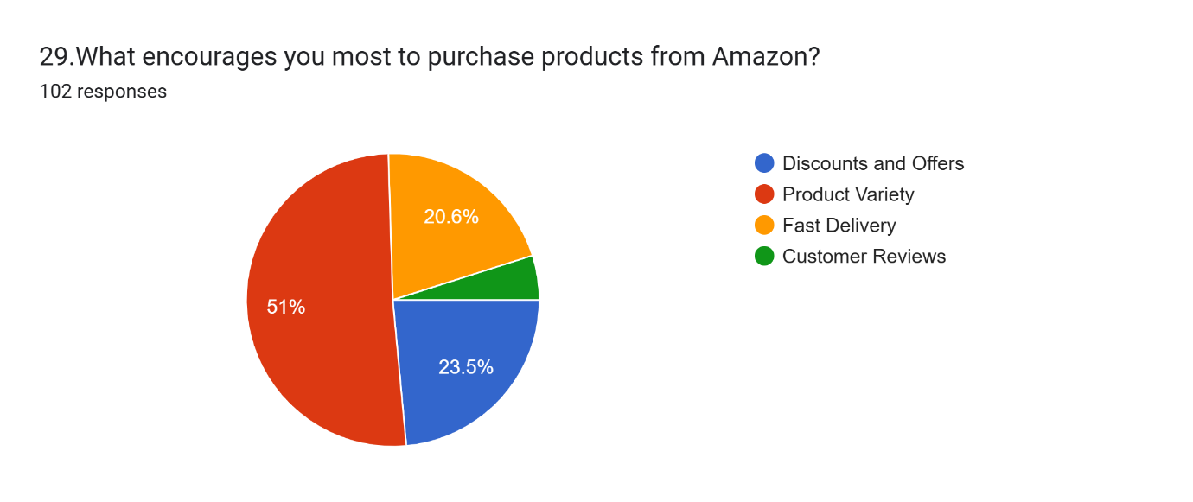
Interpretation:
The survey results show that 51% of respondents are most encouraged to purchase by product variety. Discounts and offers account for 23.5%, while fast delivery accounts for 20.6%. The remaining respondents selected customer reviews.
The findings indicate that product variety is the leading purchase motivator among the surveyed respondents. Discounts, delivery convenience, and customer reviews also contribute to purchasing decisions.
6.32 Analysis of Question 30: Perceived Online Payment Security
Question: How secure do you feel while making online payments on Amazon?
Insert Chart: 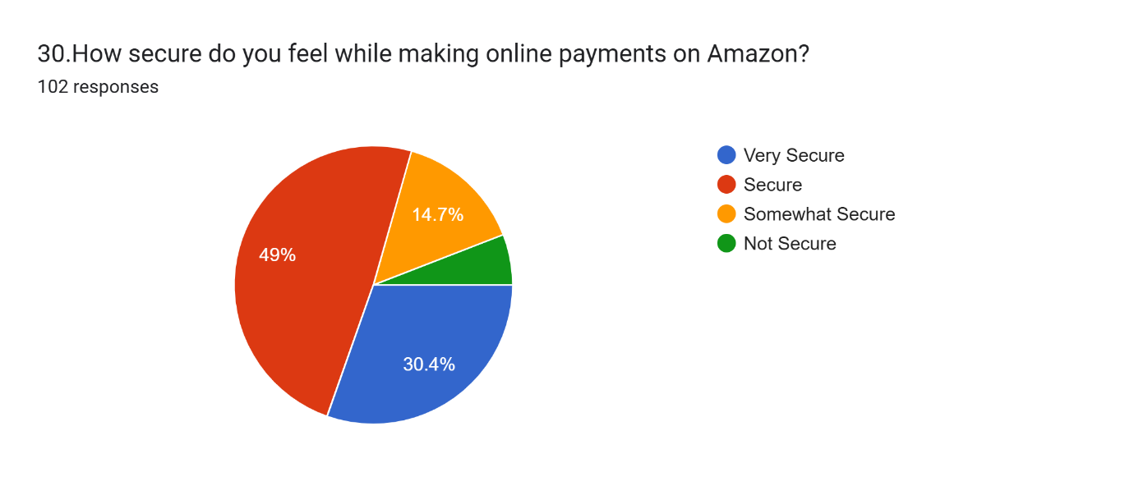
Interpretation:
The chart indicates that 49% of respondents feel secure while making online payments on Amazon, while 30.4% feel very secure. The remaining respondents feel somewhat secure or not secure.
The results suggest that most surveyed respondents feel secure when making online payments. However, clear payment information, secure payment procedures, and awareness of online safety practices remain important for maintaining customer confidence.

CHAPTER 7
MAJOR FINDINGS OF THE STUDY
7.1 Introduction
This chapter presents the major findings of the study based on the responses collected from 102 respondents regarding Amazon usage and customer satisfaction.
7.2 Major Findings
- Shopping Frequency: Monthly shopping was the most common pattern, reported by 39.2% of respondents.
- Device Preference: Mobile phones were the most commonly used devices, selected by 74.5% of respondents.
- Ease of Use: A total of 82.4% of respondents found Amazon either easy or very easy to use.
- Product Selection: Product quality was the most important purchasing factor for 52% of respondents.
- Product Reviews: Most respondents considered product reviews useful when making purchase decisions.
- Pricing: Around 69.6% of respondents considered Amazon's prices affordable or very affordable.
- Payment Preferences: Cash on Delivery was the most preferred payment method, selected by 49% of respondents.
- Payment Satisfaction: Most respondents expressed satisfaction with Ama

CHAPTER 8
SUGGESTIONS AND RECOMMENDATIONS
Based on the findings of the study, the following suggestions may help improve customer satisfaction with Amazon.
1. Competitive Pricing
Amazon should continue offering competitive prices and transparent information about product costs. Discounts and special offers may help customers find products within their budgets.
2. Improvement in Delivery Services
Amazon should focus on timely delivery, accurate delivery estimates, and clear tracking information to reduce customer concerns about delivery delays.
3. Maintaining Product Quality
Product quality should remain a priority. Reliable sellers, quality checks, and accurate product information can help customers make informed choices.
4. Accurate Product Descriptions
Product descriptions, specifications, photographs, and other details should be clear and accurate. This may reduce confusion and differences between customer expectations and received products.
5. Better Customer Support
Customer support should provide timely responses and clear solutions to complaints, payment concerns, delivery problems, and refund requests.
6. Simple Return and Refund Procedures
The return and refund process should be easy to understand. Customers should receive clear instructions and updates about the progress of their requests.
7. Secure Payment Experience
Amazon should continue maintaining secure payment processes and provide clear guidance to help customers protect their payment information.
8. Mobile-Friendly Experience
Since mobile phones are widely used by the respondents, Amazon should maintain a convenient, accessible, and user-friendly mobile shopping experience.

9. Reliable Customer Reviews
Customer reviews and ratings should be presented clearly so that shoppers can compare products and make informed decisions.
10. Continuous Customer Feedback
Regular feedback collection can help identify changing customer expectations and areas requiring improvement.
8.1 Summary
Implementing these suggestions may help address customer concerns, strengthen trust, and improve the overall shopping experience. These recommendations are based on the survey findings and represent possible areas for improvement.

CHAPTER 9
CONCLUSION
The study titled “A Study on the Usage and Customer Satisfaction of Amazon” was conducted to understand the shopping habits, preferences, and satisfaction levels of Amazon users.
The study examined several aspects of online shopping, including product selection, pricing, payment methods, delivery speed, packaging, product quality, customer service, returns, and payment security. A questionnaire was used to collect responses from 102 respondents.
The findings indicate that Amazon is generally viewed positively by the respondents. Most participants reported that the platform is easy to use, and mobile phones were the most commonly used devices for accessing Amazon. Product quality, customer reviews, and product variety emerged as important considerations in purchasing decisions.
The results also indicate positive satisfaction with payment processes, delivery speed, product quality, and customer service. Many respondents expressed a willingness to recommend Amazon to others and make future purchases.
However, the study identified high prices and delivery issues as important concerns. These findings suggest that competitive pricing, reliable delivery, accurate product descriptions, and effective customer support remain important areas for improvement.
In conclusion, Amazon provides a convenient online shopping option for the surveyed respondents. Maintaining service quality and responding to customer concerns may help improve satisfaction and encourage continued use of the platform.
The conclusions of this study are limited to the respondents who participated in the survey. They should not be treated as representing every Amazon customer.

CHAPTER 10
LIMITATIONS AND FUTURE SCOPE
10.1 Limitations of the Study
Every research study has certain limitations. The major limitations of this study are as follows:
- Limited Sample: The study is based on responses from 102 respondents, so the findings may not represent all Amazon customers.
- Limited Geographical Coverage: The results reflect the people who participated in the survey and may not represent customers from every region.
- Questionnaire-Based Research: The study relies on the answers provided by respondents through the questionnaire.
- Individual Opinions: Customer satisfaction is subjective and may vary according to personal expectations and experiences.
- Limited Study Period: The findings reflect responses collected during the survey period and may change over time.
- Limited Scope: The study focuses on selected aspects of Amazon usage and customer satisfaction rather than every feature of the platform.
10.2 Future Scope of the Study
Future studies may explore the following areas:
- A larger and more geographically diverse sample of respondents.
- A comparison of Amazon with other e-commerce platforms.
- Customer satisfaction across different product categories.
- The effect of discounts and delivery services on purchasing decisions.
- Customer experiences with returns, refunds, and complaints.
- Changes in shopping habits over time.
- Differences between mobile and desktop shopping experiences.
- The influence of ratings and reviews on customer trust.

10.3 Summary
Despite its limitations, the study provides useful insights into the shopping habits and satisfaction levels of the surveyed respondents. Further research with a larger sample and broader coverage could provide a more comprehensive understanding of customer satisfaction in e-commerce.
REFERENCES
The following sources may be used to support the background and conceptual understanding of this project. Include only the sources that you actually consult while preparing the final report.
- Amazon India. Official Website. https://www.amazon.in/
- Amazon India. Help and Customer Service Information. Available through the official Amazon India website.
- Kothari, C. R., and Garg, G. Research Methodology: Methods and Techniques. New Age International Publishers.
- Kotler, Philip, and Keller, Kevin Lane. Marketing Management. Pearson.
- E-commerce and consumer behaviour study materials consulted during the preparation of this project.
Primary Data
Primary data for this project was collected through a questionnaire prepared to study Amazon usage and customer satisfaction. The survey included 30 questions and received 102 responses.
Secondary Data
Secondary information was considered from relevant educational materials, books, and official online resources used to understand e-commerce, customer satisfaction, and online shopping behaviour.
FINAL SUMMARY
The field work project on “A Study on the Usage and Customer Satisfaction of Amazon” examined the experiences and opinions of 102 respondents.
The study covered shopping frequency, device preference, product selection, pricing, payment preferences, delivery, packaging, returns, customer service, product ratings, and overall satisfaction.
The results indicate generally positive opinions of Amazon among the respondents. Product quality and product variety were important considerations, while mobile phones were the most commonly used devices. High prices and delivery issues were identified as key concerns.
The study concludes that customer satisfaction depends on several factors, including product quality, affordability, delivery reliability, convenient payment options, and effective customer support.
This project helped develop an understanding of e-commerce and the importance of customer feedback in evaluating an online shopping platform.
— END OF PROJECT —

